

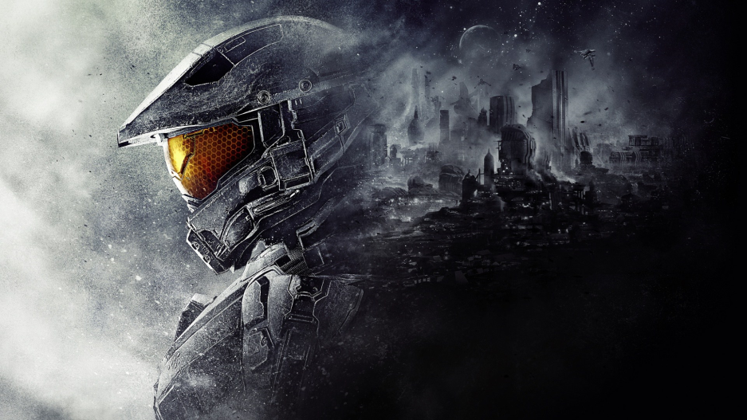

# GAME MANUAL

# SETUP

SUMMARY

Planet Earth will soon be attacked by Aliens and a space warrior is assigned the task of protecting the planet and keeping those enemies away.It will shoot anything that comes nearer.It is always trying to find enemies which are trying to evade the planet Earth.

# TYPE OF GAME

* 2 Dimensional game (2D) Shooting game.

# SYSTEM REQUIREMENTS

* Any windows OS
* Any processor with speed above 200MHz
* DirectX graphic card
* 512MB RAM
* Screen
* 1GB hard disk
* DirectX sound card
* USB 2.0 port
* Mouse and keyboard
* Speakers

# INSTALLATION GUIDE

* Open C:\Documents and Settings\Student\Desktop\FinalDemo\demofinal.exe
* Go to START>Run> then copy this to search box C:\Documents and Settings\Student\Desktop\Demofinal\demofinal.exe

## **TROUBLESHOOTING**

* Restart the game, if you encounter any error.
* If the mouse clicking does not function, make sure that you remove and install back the mouse.
* Make sure that the correct controller has been selected and its working.
* Make sure that you have the minimum requirements specified above, or update your sound and video drivers.

# TABLE OF CONTENTS

# TOPIC PAGE

1. **Identification and description 1-2**
2. **Concepts and scenario 3**
3. **Contacts and credits 4**

**IDENTIFICATION AND DESCRIPTION**

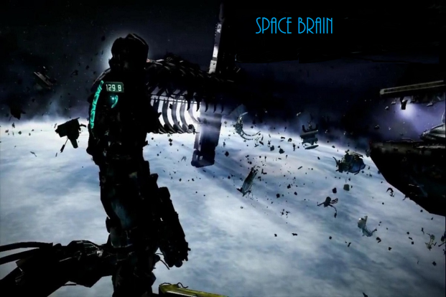

Opening screen background picture.

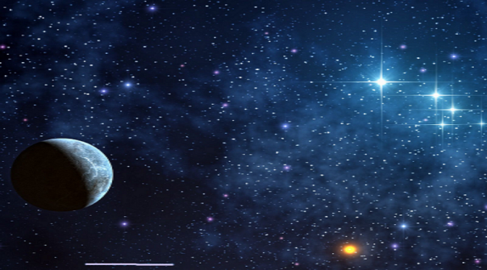

Menu background picture



To start the game Exit the game



Game play background image, to make invoke space reality

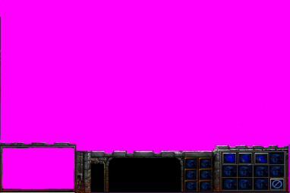

Combined with the above image, to form game play image and also to invoke mini map reality

# C:\Users\'Siya\Desktop\DemoFinal\SpaceBrain\SpaceBrainContent\images\gameOver1.png

Game over background image

CONCEPTS & SCENARIOS

# Units and objects

|  |  |  |  |  |  |
| --- | --- | --- | --- | --- | --- |
| Unit | Name | Speed | Life | Functionality | Story |

|  |  |  |  |  |  |
| --- | --- | --- | --- | --- | --- |
|  | Enemy | 5 m/s | 100%  Full life bar | Seek the user and shoot it | Consist of the best bullets ,it’s the enemy tank |
| C:\Users\'Siya\Desktop\DemoFinal\SpaceBrain\SpaceBrainContent\images\sprites\spaceship.png | User Tank | 3m/s | 100%  Full life bar | Shoot down the enemy | It’s a user controlled tank |
|  | Enemy | 6 m/s | 100%  Full life bar | Gives the user more life, | It gives the user tank more live wen it collides |

**CONTACTS AND CREDITS**

**Bibliography**

To finish this project I had to consult other sources.I would like to give credit to the Learn XNA 4.0 book and the Learning games by example ..which I have been using throughout this project.I have also been watching youtube videos that have helped a lot.Through all tough days trying to finish the project and also work on other school subjects.I would also like to remember my Games Programming lecture because without him I wouldn’t have known how to start with games.

**Contacts**

Email at **siyabd@yahoo.com** or contact the team at 0811235545

To rate the game go to [www.SPACE](http://www.SPACE)WARRIOR.co.za.